**SVKM’s NMIMS**

**School of Technology Management & Engineering, Chandigarh**

A.Y. 2023 - 24

**Course: Database Management Systems**

**Project Report**

|  |  |  |
| --- | --- | --- |
| Program | MBA Tech (CE) | |
| Semester | 4 | |
| Name of the Project: | Car Dealership | |
|  | | |
| Details of Project Members |  |  |
| Batch | Roll No. | Name |
| 2 | A192 | Richard Dsouza |
| 2 | A194 | Ashok Thaniyath |
|  |  |  |
| Date of Submission: 30-03-2024 | | |

**Contribution of each project Members:**

|  |  |  |
| --- | --- | --- |
| Roll No. | Name: | Contribution |
| A192 | Richard Dsouza |  |
| A194 | Ashok Thaniyath |  |

**Github link of your project:**

**Note:**

1. Create a readme file if you have multiple files
2. All files must be properly named (Example:R004_DBMSProject)
3. Submit all relevant files of your work ( Report, all SQL files, Any other files)
4. **Plagiarism is highly discouraged (Your report will be checked for plagiarism)**

**Rubrics for the Project evaluation:**

|  |  |
| --- | --- |
| First phase of evaluation:  Innovative Ideas (5 Marks)  Design and Partial implementation (5 Marks) | 10 marks |
| Final phase of evaluation  Implementation, presentation and viva, Self-Learning and Learning Beyond classroom | 10 marks |

**Project Report**

**Selected Topic**

**By**

**Richard Dsouza, Roll number:A192**

**Ashok Thaniyath, Roll number:A194**

**Course: DBMS**

**AY: 2023-24**

**Table of Contents**

|  |  |  |
| --- | --- | --- |
| **Sr no.** | **Topic** | **Page no.** |
| **1** | Storyline |  |
| **2** | Components of Database Design |  |
| **3** | Entity Relationship Diagram |  |
| **4** | Relational Model |  |
| **5** | Normalization |  |
| **6** | SQL Queries |  |
| **7** | Learning from the Project |  |
| **8** | Project Demonstration |  |
| **9** | Self-learning beyond classroom |  |
| **10** | Learning from the project |  |
| **8** | Challenges faced |  |
| **9** | Conclusion |  |

**I. Storyline**

After working on a project in Web Programming, We've decided to take this as our Database Management System (DBMS) project: Car Dealership. This means We will be focusing on how data is stored, managed, and used in a car dealership. By organizing information effectively, we hope to make processes smoother for customers and employees. This project will help us learn how to design and use databases effectively while solving practical problems faced by car dealerships.

**II. Components of Database Design**

CustomerDetails

Attributes:

CustomerID (PK)

Name

Email

Phone Number

Date of Birth

Car Model

Explanation:

The original Customer table was split to separate out the customer details from the car model they own. This division helps in maintaining a clear distinction between customer personal details and their associated car model.

2. CarModelDetails

Attributes:

ModelID (PK)

Model Name

Body Style

Engine Type

Horsepower

CompanyID (FK)

Explanation:

The Car Model table remains mostly the same, but it is now separated for clarity and to ensure that the company details are directly associated with each car model.

3. CompanyDetails

Attributes:

CompanyID (PK)

Company Name

Headquarters Location

Website

Year Founded

Company Revenue

Explanation:

The Company table was expanded to include additional attributes like company revenue. This information can be essential for business analytics and understanding the company's financial health.

4. VehicleDetails

Attributes:

VIN (PK)

ModelID (FK)

Purchase Date

Warranty Expiry Date

Insurance Details

Mileage

Explanation:

The Vehicle table was expanded to include more specific details related to each vehicle, such as the purchase date, warranty expiry date, insurance details, and mileage.

5. VehicleInventoryDetails

Attributes:

VIN (FK)

DealerID (FK)

Color

Made Date

Supply Date

In Location

Explanation:

The VehicleInventory table was split to separate the details related to each vehicle's inventory from the dealer details.

6. SalesDetails

Attributes:

SaleID (PK)

VIN (FK)

CustomerID (FK)

Sale Date

Sale Price

Payment Method

Explanation:

The Sales table remains mostly the same but is renamed to SalesDetails for clarity and to align with the naming convention of the decomposed tables.

7. DealerDetails

Attributes:

DealerID (PK)

Name

Location

Phone Number

BrandID (FK)

Owner Name

Explanation:

The Dealer table was expanded to include the dealer's owner name, providing more context about the dealer's ownership and management.

8. BrandDetails

Attributes:

BrandID (PK)

Brand Name

Country of Origin

Brand Ambassador

Annual Sales

Market Share

Explanation:

The Brand table was expanded to include additional attributes like brand ambassador, annual sales, and market share to provide more detailed insights into each brand.

9. InventoryDetails

Attributes:

PartID (PK)

Part Name

Description

Supplier

Cost Price

Stock Quantity

Explanation:

The Inventory table remains mostly the same but is renamed to InventoryDetails for clarity and to align with the naming convention of the decomposed tables.

10. VehiclePartDetails

Attributes:

VIN (FK)

PartID (FK)

Quantity

Installed Date

Warranty Period

Maintenance Schedule

Explanation:

The VehiclePart table was expanded to include more specific details related to each vehicle part, such as the warranty period and maintenance schedule.

11. SupplierDetails

Attributes:

SupplierID (PK)

Company Name

Contact Name

Contact Email

Phone Number

Address

Explanation:

The Supplier table was expanded to include the supplier's address, providing more comprehensive supplier information.

12. EmployeeDetails

Attributes:

EmployeeID (PK)

Name

Job Title

Hire Date

Department

Salary

Explanation:

The Employee table was expanded to include the employee's salary, providing more context about the employee's compensation and role within the company.

13. TestDriveDetails

Attributes:

TestDriveID (PK)

CustomerID (FK)

VIN (FK)

Date

SalespersonID (FK)

Feedback

**III. Entity Relationship Diagram**

Draw the ER diagram here. An example is shown:

You can also use software for drawing ER diagram

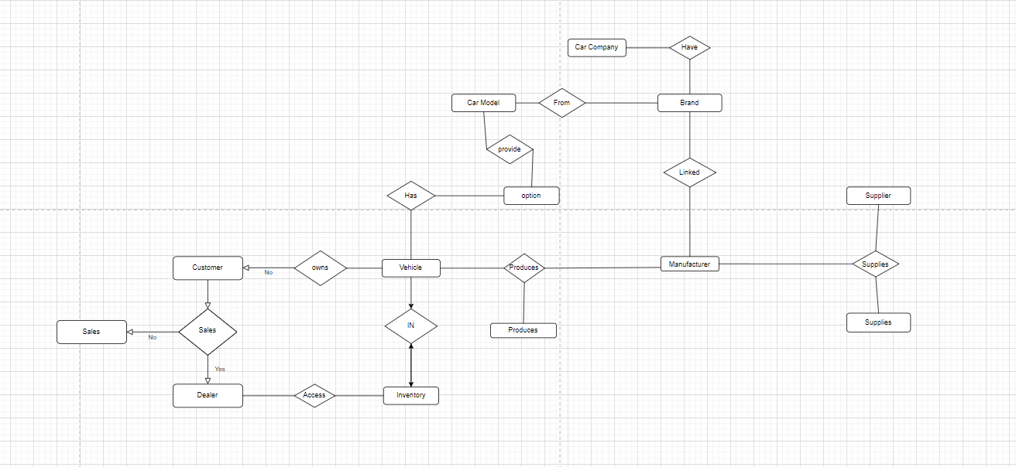

After Normalization:

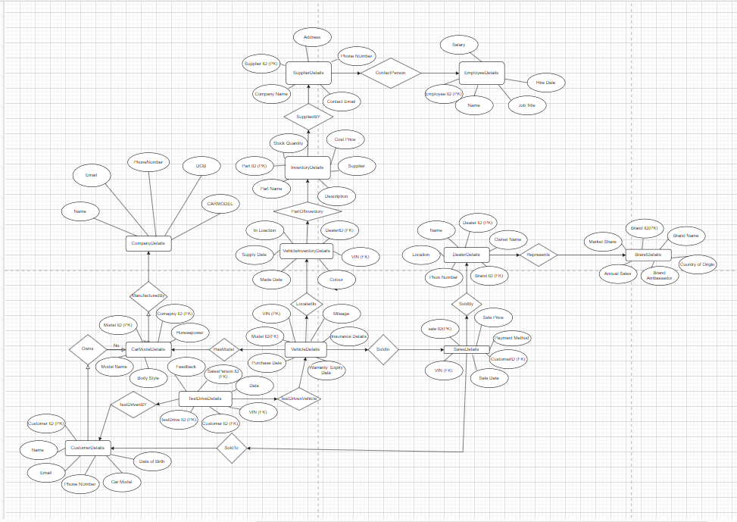

**IV. Relational Model**

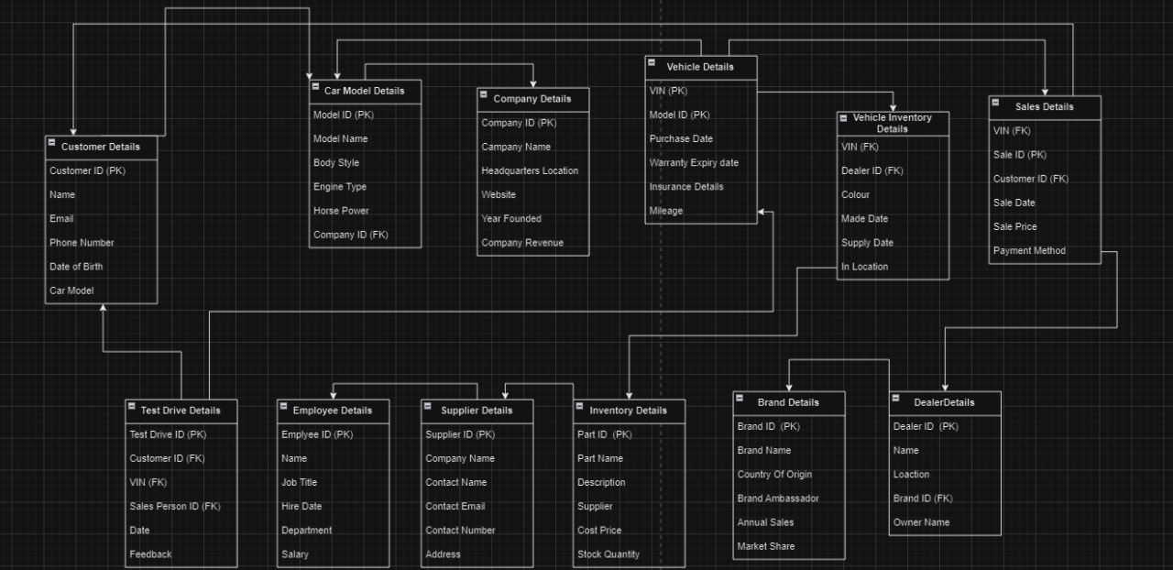

**V. Normalization**

Perform normalization (1NF, 2NF, 3NF, BCNF) as applicable for the entire database.

* **Customer** table: This table likely stores information about customers such as their name, address, phone number, gender, and annual income.
* **Car Model** table: This table likely stores information about car models such as the model ID, model name, body style, and model year.
* **Company** table: This table likely stores information about car companies such as their company ID, company name, and number of employees. It also has a foreign key that references the Brand Name table.
* **Vehicle** table: This table likely stores information about vehicles such as their VIN (Vehicle Identification Number), brand name, and number of employees. It also has foreign keys that reference the Model Name table, Inventory table, and COMID table.
* **Sales** table: This table likely stores information about sales such as the VIN, date, price, color, and supplier. It also has foreign keys that reference the Customer ID table, Model Name table, and Inventory table.
* **Dealer** table: This table likely stores information about dealers such as their dealer ID, name, and location. It also has a foreign key that references the Model ID table.
* **Inventory** table: This table likely stores information about car inventory such as the VIN, in name (possibly the location of the car), in location (possibly the specific location of the car within a dealership or lot), part type, part ID, made date, and supply date. It also has a foreign key that references the Dealer ID table.
* **Brand** table: This table is not fully depicted in the ERD, but based on the foreign keys from other tables, it likely stores information about car brands.

**VI. SQL Queries**

Using a DBMS software (SQLite3 or MySQL or any other of your choice):

* Create the tables
* Populate the tables (insert some meaningful data, at least 10 tuples for each relation)
* Run SQL queries (minimum 20) covering **all concepts** learned in the class

This section should contain the question, SQL code, and the output snapshot for each query.

create database project;  
use project ;

-- 1. CustomerDetails  
CREATE TABLE CustomerDetails (  
 CustomerID INT PRIMARY KEY,  
 Name VARCHAR(255),  
 Email VARCHAR(255),  
 PhoneNumber VARCHAR(15),  
 DateOfBirth DATE,  
 CarModel VARCHAR(255)  
);  
  
-- 2. CarModelDetails  
CREATE TABLE CarModelDetails (  
 ModelID INT PRIMARY KEY,  
 ModelName VARCHAR(255),  
 BodyStyle VARCHAR(50),  
 EngineType VARCHAR(50),  
 Horsepower INT,  
 CompanyID INT,  
 FOREIGN KEY (CompanyID) REFERENCES CompanyDetails(CompanyID) ON DELETE CASCADE  
);  
  
-- 3. CompanyDetails  
CREATE TABLE CompanyDetails (  
 CompanyID INT PRIMARY KEY,  
 CompanyName VARCHAR(255),  
 HeadquartersLocation VARCHAR(255),  
 Website VARCHAR(255),  
 YearFounded INT,  
 CompanyRevenue DECIMAL(15, 2)  
);  
  
-- 4. VehicleDetails  
CREATE TABLE VehicleDetails (  
 VIN VARCHAR(17) PRIMARY KEY,  
 ModelID INT,  
 PurchaseDate DATE,  
 WarrantyExpiryDate DATE,  
 InsuranceDetails TEXT,  
 Mileage INT,  
 FOREIGN KEY (ModelID) REFERENCES CarModelDetails(ModelID) ON DELETE CASCADE  
);  
  
-- 5. VehicleInventoryDetails  
CREATE TABLE VehicleInventoryDetails (  
 VIN VARCHAR(17),  
 DealerID INT,  
 Color VARCHAR(50),  
 MadeDate DATE,  
 SupplyDate DATE,  
 InLocation VARCHAR(255),  
 PRIMARY KEY (VIN, DealerID),  
 FOREIGN KEY (VIN) REFERENCES VehicleDetails(VIN) ON DELETE CASCADE,  
 FOREIGN KEY (DealerID) REFERENCES DealerDetails(DealerID) ON DELETE CASCADE  
);  
  
-- 6. SalesDetails  
CREATE TABLE SalesDetails (  
 SaleID INT PRIMARY KEY,  
 VIN VARCHAR(17),  
 CustomerID INT,  
 SaleDate DATE,  
 SalePrice DECIMAL(10, 2),  
 PaymentMethod VARCHAR(50),  
 FOREIGN KEY (VIN) REFERENCES VehicleDetails(VIN) ON DELETE CASCADE,  
 FOREIGN KEY (CustomerID) REFERENCES CustomerDetails(CustomerID) ON DELETE CASCADE  
);  
  
-- 7. DealerDetails  
CREATE TABLE DealerDetails (  
 DealerID INT PRIMARY KEY,  
 Name VARCHAR(255),  
 Location VARCHAR(255),  
 PhoneNumber VARCHAR(15),  
 BrandID INT,  
 OwnerName VARCHAR(255),  
 FOREIGN KEY (BrandID) REFERENCES BrandDetails(BrandID) ON DELETE CASCADE  
);  
  
-- 8. BrandDetails  
CREATE TABLE BrandDetails (  
 BrandID INT PRIMARY KEY,  
 BrandName VARCHAR(255),  
 CountryOfOrigin VARCHAR(100),  
 BrandAmbassador VARCHAR(255),  
 AnnualSales DECIMAL(15, 2),  
 MarketShare DECIMAL(5, 2)  
);  
  
-- 9. InventoryDetails  
CREATE TABLE InventoryDetails (  
 PartID INT PRIMARY KEY,  
 PartName VARCHAR(255),  
 Description TEXT,  
 Supplier VARCHAR(255),  
 CostPrice DECIMAL(10, 2),  
 StockQuantity INT  
);  
  
-- 10. VehiclePartDetails  
CREATE TABLE VehiclePartDetails (  
 VIN VARCHAR(17),  
 PartID INT,  
 Quantity INT,  
 InstalledDate DATE,  
 WarrantyPeriod INT,  
 MaintenanceSchedule TEXT,  
 PRIMARY KEY (VIN, PartID),  
 FOREIGN KEY (VIN) REFERENCES VehicleDetails(VIN) ON DELETE CASCADE,  
 FOREIGN KEY (PartID) REFERENCES InventoryDetails(PartID) ON DELETE CASCADE  
);  
  
-- 11. SupplierDetails  
CREATE TABLE SupplierDetails (  
 SupplierID INT PRIMARY KEY,  
 CompanyName VARCHAR(255),  
 ContactName VARCHAR(255),  
 ContactEmail VARCHAR(255),  
 PhoneNumber VARCHAR(15),  
 Address TEXT  
);  
  
-- 12. EmployeeDetails  
CREATE TABLE EmployeeDetails (  
 EmployeeID INT PRIMARY KEY,  
 Name VARCHAR(255),  
 JobTitle VARCHAR(100),  
 HireDate DATE,  
 Department VARCHAR(100),  
 Salary DECIMAL(10, 2)  
);  
  
-- 13. TestDriveDetails  
CREATE TABLE TestDriveDetails (  
 TestDriveID INT PRIMARY KEY,  
 CustomerID INT,  
 VIN VARCHAR(17),  
 Date DATE,  
 SalespersonID INT,  
 Feedback TEXT,  
 FOREIGN KEY (CustomerID) REFERENCES CustomerDetails(CustomerID) ON DELETE CASCADE,  
 FOREIGN KEY (VIN) REFERENCES VehicleDetails(VIN) ON DELETE CASCADE,  
 FOREIGN KEY (SalespersonID) REFERENCES EmployeeDetails(EmployeeID) ON DELETE CASCADE  
);  
  
  
-- 1. CustomerDetails  
INSERT INTO CustomerDetails (CustomerID, Name, Email, PhoneNumber, DateOfBirth, CarModel)  
VALUES  
(1, 'John Doe', 'johndoe@email.com', '123-456-7890', '1990-01-01', 'Sedan'),  
(2, 'Jane Smith', 'janesmith@email.com', '987-654-3210', '1992-05-15', 'SUV'),  
(3, 'Alice Johnson', 'alice@email.com', '111-222-3333', '1985-07-20', 'Hatchback'),  
(4, 'Bob Williams', 'bob@email.com', '444-555-6666', '1988-03-10', 'Coupe'),  
(5, 'Charlie Brown', 'charlie@email.com', '777-888-9999', '1995-11-25', 'Sedan'),  
(6, 'David Davis', 'david@email.com', '666-555-4444', '1980-09-30', 'SUV'),  
(7, 'Eva Green', 'eva@email.com', '222-333-4444', '1993-12-15', 'Hatchback');  
  
-- 2. CarModelDetails  
INSERT INTO CarModelDetails (ModelID, ModelName, BodyStyle, EngineType, Horsepower, CompanyID)  
VALUES  
(1, 'Model S', 'Sedan', 'Electric', 500, 1),  
(2, 'Model X', 'SUV', 'Electric', 450, 1),  
(3, 'Model 3', 'Hatchback', 'Electric', 350, 1),  
(4, 'Model Y', 'SUV', 'Electric', 450, 1),  
(5, 'Civic', 'Sedan', 'Gasoline', 180, 2),  
(6, 'CR-V', 'SUV', 'Gasoline', 190, 2),  
(7, 'Accord', 'Coupe', 'Gasoline', 200, 2);  
  
-- 3. CompanyDetails  
INSERT INTO CompanyDetails (CompanyID, CompanyName, HeadquartersLocation, Website, YearFounded, CompanyRevenue)  
VALUES  
(1, 'Tesla', 'Palo Alto, CA', 'https://www.tesla.com', 2003, 40000000000),  
(2, 'Honda', 'Tokyo, Japan', 'https://www.honda.com', 1946, 10000000000),  
(3, 'Toyota', 'Toyota City, Japan', 'https://www.toyota.com', 1937, 20000000000),  
(4, 'Ford', 'Dearborn, MI', 'https://www.ford.com', 1903, 30000000000),  
(5, 'Chevrolet', 'Detroit, MI', 'https://www.chevrolet.com', 1911, 25000000000),  
(6, 'BMW', 'Munich, Germany', 'https://www.bmw.com', 1916, 35000000000),  
(7, 'Mercedes-Benz', 'Stuttgart, Germany', 'https://www.mercedes-benz.com', 1926, 30000000000);  
  
-- 4. VehicleDetails  
INSERT INTO VehicleDetails (VIN, ModelID, PurchaseDate, WarrantyExpiryDate, InsuranceDetails, Mileage)  
VALUES  
('VIN12345678901234', 1, '2023-01-15', '2026-01-15', 'Full Coverage', 5000),  
('VIN23456789012345', 2, '2022-05-20', '2025-05-20', 'Liability Only', 6000),  
('VIN34567890123456', 3, '2023-03-10', '2026-03-10', 'Full Coverage', 4000),  
('VIN45678901234567', 4, '2022-07-05', '2025-07-05', 'Liability Only', 5500),  
('VIN56789012345678', 5, '2021-11-30', '2024-11-30', 'Full Coverage', 7000),  
('VIN67890123456789', 6, '2020-09-25', '2023-09-25', 'Liability Only', 8000),  
('VIN78901234567890', 7, '2022-04-15', '2025-04-15', 'Full Coverage', 6500);  
  
-- 5. VehicleInventoryDetails  
INSERT INTO VehicleInventoryDetails (VIN, DealerID, Color, MadeDate, SupplyDate, InLocation)  
VALUES  
('VIN12345678901234', 1, 'Red', '2023-01-10', '2023-01-12', 'Warehouse A'),  
('VIN23456789012345', 2, 'Blue', '2022-05-15', '2022-05-18', 'Warehouse B'),  
('VIN34567890123456', 3, 'White', '2023-03-05', '2023-03-08', 'Warehouse C'),  
('VIN45678901234567', 4, 'Black', '2022-07-01', '2022-07-03', 'Warehouse D'),  
('VIN56789012345678', 5, 'Silver', '2021-11-25', '2021-11-28', 'Warehouse E'),  
('VIN67890123456789', 6, 'Gray', '2020-09-20', '2020-09-23', 'Warehouse F'),  
('VIN78901234567890', 7, 'Green', '2022-04-10', '2022-04-13', 'Warehouse G');  
  
-- 6. SalesDetails  
INSERT INTO SalesDetails (SaleID, VIN, CustomerID, SaleDate, SalePrice, PaymentMethod)  
VALUES  
(1, 'VIN12345678901234', 1, '2023-01-20', 60000.00, 'Credit Card'),  
(2, 'VIN23456789012345', 2, '2022-05-25', 70000.00, 'Bank Transfer'),  
(3, 'VIN34567890123456', 3, '2023-03-15', 55000.00, 'Cash'),  
(4, 'VIN45678901234567', 4, '2022-07-10', 65000.00, 'Credit Card'),  
(5, 'VIN56789012345678', 5, '2021-12-05', 75000.00, 'Bank Transfer'),  
(6, 'VIN67890123456789', 6, '2020-10-01', 50000.00, 'Cash'),  
(7, 'VIN78901234567890', 7, '2022-04-20', 68000.00, 'Credit Card');  
  
-- 7. DealerDetails  
INSERT INTO DealerDetails (DealerID, Name, Location, PhoneNumber, BrandID, OwnerName)  
VALUES  
(1, 'Tesla Palo Alto', 'Palo Alto, CA', '123-456-7890', 1, 'Elon Musk'),  
(2, 'Honda Tokyo', 'Tokyo, Japan', '987-654-3210', 2, 'Takahiro Hachigo'),  
(3, 'Toyota Toyota City', 'Toyota City, Japan', '111-222-3333', 3, 'Akio Toyoda'),  
(4, 'Ford Dearborn', 'Dearborn, MI', '444-555-6666', 4, 'Jim Farley'),  
(5, 'Chevrolet Detroit', 'Detroit, MI', '777-888-9999', 5, 'Mary Barra'),  
(6, 'BMW Munich', 'Munich, Germany', '666-555-4444', 6, 'Oliver Zipse'),  
(7, 'Mercedes-Benz Stuttgart', 'Stuttgart, Germany', '222-333-4444', 7, 'Ola Källenius');  
  
-- 8. BrandDetails  
INSERT INTO BrandDetails (BrandID, BrandName, CountryOfOrigin, BrandAmbassador, AnnualSales, MarketShare)  
VALUES  
(1, 'Tesla', 'USA', 'Elon Musk', 100000, 25.0),  
(2, 'Honda', 'Japan', 'Takahiro Hachigo', 2000000, 15.0),  
(3, 'Toyota', 'Japan', 'Akio Toyoda', 3000000, 20.0),  
(4, 'Ford', 'USA', 'Jim Farley', 1500000, 10.0),  
(5, 'Chevrolet', 'USA', 'Mary Barra', 1200000, 10.0),  
(6, 'BMW', 'Germany', 'Oliver Zipse', 800000, 7.0),  
(7, 'Mercedes-Benz', 'Germany', 'Ola Källenius', 1000000, 13.0);  
  
-- 9. InventoryDetails  
INSERT INTO InventoryDetails (PartID, PartName, Description, Supplier, CostPrice, StockQuantity)  
VALUES  
(1, 'Tire', 'All-weather tire', 'Supplier A', 100.00, 200),  
(2, 'Brake Pad', 'High-performance brake pad', 'Supplier B', 50.00, 300),  
(3, 'Battery', 'Electric vehicle battery', 'Supplier C', 2000.00, 100),  
(4, 'Oil Filter', 'Premium oil filter', 'Supplier D', 20.00, 400),  
(5, 'Headlight', 'LED headlight', 'Supplier E', 150.00, 250),  
(6, 'Windshield Wiper', 'Rain-sensing wiper', 'Supplier F', 30.00, 350),  
(7, 'Radiator', 'High-efficiency radiator', 'Supplier G', 300.00, 150);  
  
-- 10. VehiclePartDetails  
INSERT INTO VehiclePartDetails (VIN, PartID, Quantity, InstalledDate, WarrantyPeriod, MaintenanceSchedule)  
VALUES  
('VIN12345678901234', 1, 4, '2023-01-18', 5, 'Every 6 months'),  
('VIN23456789012345', 2, 2, '2022-05-22', 4, 'Every 4 months'),  
('VIN34567890123456', 3, 1, '2023-03-12', 6, 'Every 7 months'),  
('VIN45678901234567', 4, 3, '2022-07-07', 5, 'Every 5 months'),  
('VIN56789012345678', 5, 2, '2021-11-28', 4, 'Every 4 months'),  
('VIN67890123456789', 6, 1, '2020-09-28', 6, 'Every 8 months'),  
('VIN78901234567890', 7, 2, '2022-04-17', 5, 'Every 6 months');  
  
-- 11. SupplierDetails  
INSERT INTO SupplierDetails (SupplierID, CompanyName, ContactName, ContactEmail, PhoneNumber, Address)  
VALUES  
(1, 'Supplier A Co.', 'John Doe', 'john.doe@supplierA.com', '123-456-7890', '123 Supplier St, City A'),  
(2, 'Supplier B Co.', 'Jane Smith', 'jane.smith@supplierB.com', '987-654-3210', '456 Supplier St, City B'),  
(3, 'Supplier C Co.', 'Alice Johnson', 'alice.johnson@supplierC.com', '111-222-3333', '789 Supplier St, City C'),  
(4, 'Supplier D Co.', 'Bob Williams', 'bob.williams@supplierD.com', '444-555-6666', '012 Supplier St, City D'),  
(5, 'Supplier E Co.', 'Charlie Brown', 'charlie.brown@supplierE.com', '777-888-9999', '345 Supplier St, City E'),  
(6, 'Supplier F Co.', 'David Davis', 'david.davis@supplierF.com', '666-555-4444', '678 Supplier St, City F'),  
(7, 'Supplier G Co.', 'Eva Green', 'eva.green@supplierG.com', '222-333-4444', '901 Supplier St, City G');  
  
-- 12. EmployeeDetails  
INSERT INTO EmployeeDetails (EmployeeID, Name, JobTitle, HireDate, Department, Salary)  
VALUES  
(1, 'John Doe', 'Sales Manager', '2015-01-10', 'Sales', 80000.00),  
(2, 'Jane Smith', 'Mechanic', '2017-03-15', 'Service', 50000.00),  
(3, 'Alice Johnson', 'Finance Manager', '2018-05-20', 'Finance', 85000.00),  
(4, 'Bob Williams', 'HR Manager', '2016-04-10', 'Human Resources', 75000.00),  
(5, 'Charlie Brown', 'Marketing Manager', '2019-02-28', 'Marketing', 82000.00),  
(6, 'David Davis', 'Service Advisor', '2020-06-10', 'Service', 55000.00),  
(7, 'Eva Green', 'Parts Manager', '2017-08-15', 'Parts', 60000.00);  
  
-- 13. TestDriveDetails  
INSERT INTO TestDriveDetails (TestDriveID, CustomerID, VIN, Date, SalespersonID, Feedback)  
VALUES  
(1, 1, 'VIN12345678901234', '2023-01-22', 1, 'Excellent driving experience'),  
(2, 2, 'VIN23456789012345', '2022-05-28', 2, 'Smooth ride but expensive'),  
(3, 3, 'VIN34567890123456', '2023-03-18', 3, 'Great handling and features'),  
(4, 4, 'VIN45678901234567', '2022-07-12', 4, 'Good performance but noisy'),  
(5, 5, 'VIN56789012345678', '2021-12-08', 5, 'Comfortable seats and good mileage'),  
(6, 6, 'VIN67890123456789', '2020-10-03', 6, 'Powerful engine but lacks features'),  
(7, 7, 'VIN78901234567890', '2022-04-22', 7, 'Decent car for the price');  
  
  
-- 1. CustomerDetails  
SELECT * FROM CustomerDetails;  
  
-- 2. CarModelDetails  
SELECT * FROM CarModelDetails;  
  
-- 3. CompanyDetails  
SELECT * FROM CompanyDetails;  
  
-- 4. VehicleDetails  
SELECT * FROM VehicleDetails;  
  
-- 5. VehicleInventoryDetails  
SELECT * FROM VehicleInventoryDetails;  
  
-- 6. SalesDetails  
SELECT * FROM SalesDetails;  
  
-- 7. DealerDetails  
SELECT * FROM DealerDetails;  
  
-- 8. BrandDetails  
SELECT * FROM BrandDetails;  
  
-- 9. InventoryDetails  
SELECT * FROM InventoryDetails;  
  
-- 10. VehiclePartDetails  
SELECT * FROM VehiclePartDetails;  
  
-- 11. SupplierDetails  
SELECT * FROM SupplierDetails;  
  
-- 12. EmployeeDetails  
SELECT * FROM EmployeeDetails;  
  
-- 13. TestDriveDetails  
SELECT * FROM TestDriveDetails;  
  
  
  
-- 10 Question  
-- 1st (Retrieve the total sales amount from the SalesDetails table.  
  
SELECT *SUM*(SalePrice) AS TotalSalesAmount FROM SalesDetails;  
  
-- 2nd (Calculate the average mileage of all vehicles in the VehicleDetails table.  
SELECT *AVG*(Mileage) AS AverageMileage FROM VehicleDetails;  
  
-- 3rd (SELECT MAX(WarrantyPeriod) AS MaxWarrantyPeriod FROM VehiclePartDetails;  
  
SELECT *MAX*(WarrantyPeriod) AS MaxWarrantyPeriod FROM VehiclePartDetails;  
  
-- 4th (Count the number of dealers associated with each brand in the DealerDetails table.  
SELECT BrandName, *COUNT*(DealerID) AS NumberOfDealers  
FROM BrandDetails  
JOIN DealerDetails ON BrandDetails.BrandID = DealerDetails.BrandID  
GROUP BY BrandName;  
  
-- 5th (Calculate the total cost of all parts in the inventory from the InventoryDetails table.  
SELECT *SUM*(CostPrice * StockQuantity) AS TotalInventoryCost FROM InventoryDetails;  
  
-- 6th (Retrieve the names of customers along with the car models they own.  
SELECT c.Name AS CustomerName, cmd.ModelName AS CarModel  
FROM CustomerDetails c  
JOIN VehicleDetails vd ON c.CarModel = vd.VIN  
JOIN CarModelDetails cmd ON vd.ModelID = cmd.ModelID;  
  
-- 7th (List the sales made by each dealer from the SalesDetails table.  
  
SELECT dd.Name AS DealerName, *COUNT*(sd.SaleID) AS NumberOfSales  
FROM DealerDetails dd  
LEFT JOIN VehicleInventoryDetails vid ON dd.DealerID = vid.DealerID  
LEFT JOIN SalesDetails sd ON vid.VIN = sd.VIN  
GROUP BY dd.Name;  
  
-- 8th (Find the customers who have not made any purchases.  
SELECT Name  
FROM CustomerDetails  
WHERE CustomerID NOT IN (SELECT DISTINCT CustomerID FROM SalesDetails);  
  
  
-- 9th (Identify the car model with the highest sale price.v  
  
SELECT ModelName  
FROM CarModelDetails  
WHERE ModelID = (  
 SELECT ModelID  
 FROM SalesDetails  
 ORDER BY SalePrice DESC  
 LIMIT 1  
);  
 -- 10th(Find the suppliers of the most commonly used part in the inventory.  
 SELECT CompanyName  
FROM SupplierDetails  
WHERE SupplierID = (  
 SELECT PartID  
 FROM VehiclePartDetails  
 GROUP BY PartID  
 ORDER BY *COUNT*(VIN) DESC  
 LIMIT 1  
);

**VI. Project demonstration**

* Tools/software/ libraries used
* Screenshot and Description of the Demonstration of project ( If GUI is made)

**VII. Self -Learning beyond classroom**

:

* We learnt how to create and Implement a Dealership Project on SQL and find the Relationship between each Entity and hence could Find the specific selected Queries and Outputs as needed when and where we needed to find the Output to Queries.
* new aspects did you learn on your own ? You have to mention learning beyond the classroom

**VIII. Learning from the Project**

Include learning from the project:

* How this project helped you?

We learnt how to Create a Database and Implement the topic that we chose (Car Dealership) and get specified Outputs based on Constraints with the help of Using various Queries and Finding the Realations between each Entity in the Database.

**IX. Challenges Faced**

We faced a lot of challenges while creating the Project like we were not able to get the Desired Output as needed and hence we needed to Recheck every line of code that we wrote hence it took us a lot of hours in completing the project. We also faced challenge when we were making the ER Model and Relational Model which took us time to understand and Rectify the Problems.

**X. Conclusion**

* What are the key takeaways from the project?
* We learnt how to Create And Implement a Database Management Project on Car Dealership Specifically and with that we were also able to find the Relationship of every Entity with every other Entity which has helped us a lot in Finding the similarities and Differences between each Table.